FOREMEN’S UNION
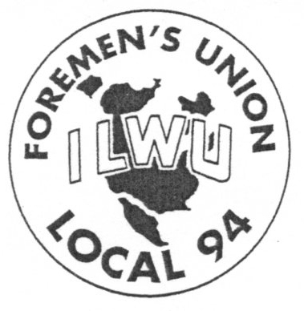
411 North Harbor Blvd., Ste. 303 San Pedro, California 90731

JUNE 5, 2010
(310) 832-1109 – (310) 832-1079 – FAX (310) 832-2142

ATTENTION: MEMBERS ILWU LOCAL 94
It has come to our attention that recent cases of vandalism, continue to occur in the men’s restrooms at P400.
While PMA and APMT are concerned with the vandalism, Local 94 is also concerned with the substance, to which we all agree, is a violation of Section 13.2 and a hate crime in the eyes of the Law.
APMT has gone to great lengths to both investigate and deter this behavior and seeks our assistance in both communicating to the Longshore workers we are responsible to supervise and provide a Non-Discriminatory Environment. APMT has acted swiftly and deliberately in an effort to provide a non-discriminatory work environment for their employees working under the jurisdiction of the PCL&CA.
We have been requested to ensure that this deliberate misconduct is stopped. We request you notify APMT Management of any misconduct that you observe or are informed of.
We appreciate your leadership as it pertains to this issue.

Sincerely,
Local 94 Officers

